COMP 2230
Lab #4
Findings

Exercise 1 (B):

Algorithm Worst Case Complexity Average Case Complexity

Bubble Sort : (n^2) (n^2)

Insertion Sort : (n^2) (n^2)

Selection Sort : (n^2) (n^2)

Merge Sort : (n log n) (n log n)

Quick Sort : (n^2) (n log n)

(C):

i: Bubble Sort

Degree of polynomial (n) Evaluation time (millisecs)

500 31
1000 46
10000 479
100000 40371
200000 171386

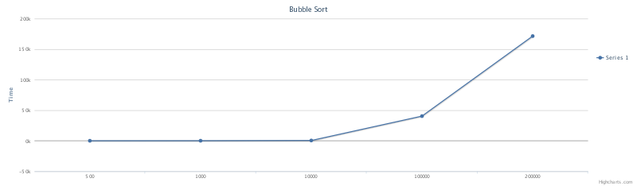
ii: Insertion Sort

Degree of polynomial (n) Evaluation time (millisecs)

500 0
1000 0
10000 46
100000 2343
200000 9435

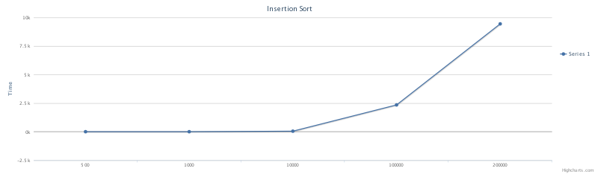

iii: Selection Sort

Degree of polynomial (n) Evaluation time (millisecs)

500 0
1000 15
10000 172
100000 15948
200000 63683

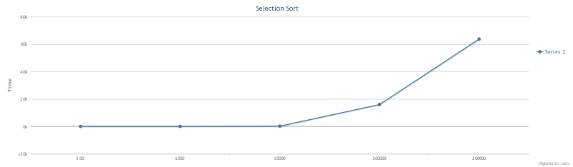

iv: Merge Sort

Degree of polynomial (n) Evaluation time (millisecs)

500 0
1000 0
10000 16
100000 94
200000 188

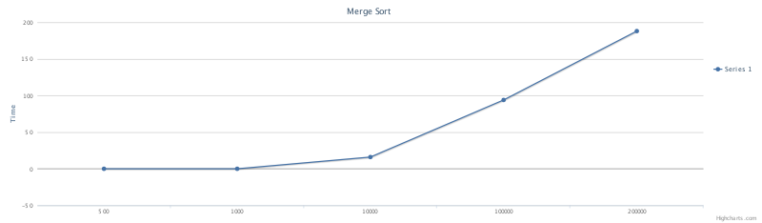

v: Quick Sort

Degree of polynomial (n) Evaluation time (millisecs)

500 0
1000 0
10000 16
100000 172
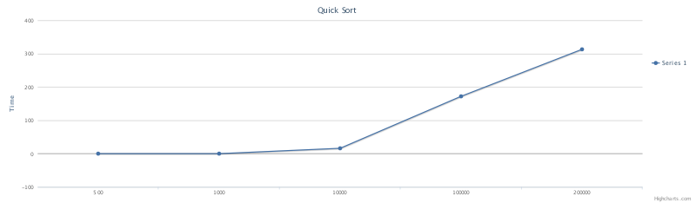
200000 313

(D):

Report

After spending some time experimenting with the different algorithms, it is obvious which one's work better then others. Another note I would like to make is it seems the times on each algorithm were slightly different every time I executed them, but after running them a couple of times I wound up sticking with the results.
Overall Bubble Sort came out the absolute worst. Starting each algorithm with n = 500: Bubble Sort's curve came out immediately. This doesn't mean it was slow though because it was close to 0 milliseconds regardless. As I continued to test Bubble Sort with larger data, things really started taking a very long time after 10'000, causing it to take about 40 seconds to execute and even over 2 minutes at 200'000. It seems that Bubble Sort is best used sticking with smaller amounts of data. Larger collections of data are probably best sorted using a different algorithm.
Selection Sort turned out to be the second worst in terms of speed yet it is still drastically better then Bubble Sort. The curve of Selection Sort does not start until you hit around n = 100'000, taking the sort about 16 seconds to execute around that time. That's still less then half of what it takes Bubble Sort to execute in terms of speed. A worst case scenario is still massive collections of data, but it doesn't mean that Selection Sort isn't a viable choice for anything under it.
An even better choice has to be Insertion Sort, coming in as the third fastest sorting algorithm. Insertion Sort can handle most data sets rather quickly, not getting a curve until n = 100'000 like most other algorithms. It only takes roughly 2 seconds to sort that much data which is rather fast, especially compared to Selection Sort which took roughly 16 seconds. That is a rather large speed difference once again.
Lastly it boils down to the last two, and very clearly fastest algorithms of the bunch, Merge Sort and Quick Sort. As I tested these two algorithms it became clear that their speeds swayed back in forth, one becoming faster then the other and vice versa. The final results I chose shows that Merge Sort wound up being slightly faster which i found interesting considering I know that Quick Sort was supposedly, well, quicker. The curve of both are generally very little compared to the other Sorts in this experiment, both not really starting until you start dealing with incredibly large sets of data. Even when n = 100'000 it only takes 0.016 seconds for them to actually sort all of that data. That is insanely fast compared to every other Sort on this list.
Ultimately choosing what Sorting algorithm boils down to the situation at hand. Though it seems if you have smaller sets of data that you are dealing with, you can choose the Sorts such as Bubble Sort or Selection Sort. If you have a massive amount of data you need to get sorted though, you should be using Merge Sort or Quick Sort as they can get the job done incredibly quickly compared to others.

Exercise 2 Findings

Size of matrix (n) Multiplication time (millisecs)
100 379
200 10416
300 39210
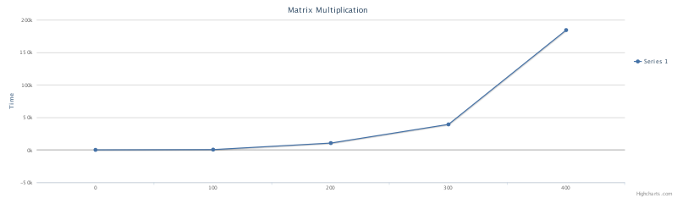
400 184189

java.lang.OutOfMemoryError: Java Heap Space:

When creating a Java program, they are actually only allowed to use a certain amount of data. As well as this, Java memory is separated into two different regions: Heap Space and Permgen. Unless specified in the Java program creation, Java will automatically assign the default sizes for both. Now the error will throw when you are trying to store data into the Heap Space and there simply just isn't enough room there to store it.

Exercise 3 Findings

Value of n Time to generate 2 power n binary numbers (millisecs)
10 0
20 157
30 99143
40 212160
